1. Font : Arial 12
2. Spacing : Double Space
3. Margins : Left and Top – 1 inch, Right and Bottom – 1 inch
4. Page : Right Hand Top corner



**ABC COMPANY**

**INFORMATION SECURITY PLAN**

A Project

Presented to the College of Information Technology and Engineering

Information Technology Department

In Partial Requirement for the course

Information Security

Submitted by:

Cean Darius Katigbak

Arvin Zoleta

Brian Ronnie Hernandez

Mark Regie Aquino

Wryce Eyriel Hizon

Nov 26, 2024

**TABLE OF CONTENTS**

Executive Summary i

List of Figures ii

List of Tables iii

Chapter 1 – Introduction

Company Background 1

Statement of the Problem 3

Objectives of the Plan 4

Scope and Delimitations 6

Definition of Terms 8

Chapter 2 - Requirements Analysis

Asset Inventory List 10

Current Physical Controls 11

Current Technical Controls 15

Risk Analysis 22

Proposed Physical Controls 24

Proposed Technical Controls 29

Chapter 3 – Security Plans

Proposed Security Policies 30

Implementation Schedule 35

**LIST OF FIGURES**

**LIST OF TABLES**

**CHAPTER 1**

**INTRODUCTION**

***Provide a background of the company***

ADS Copy Writing Center is a versatile shop operating within the premises of De La Salle Lipa, offering a wide range of services tailored to meet the academic and administrative needs of the school community. Established to provide convenience and accessibility, ADS has become an essential part of daily operations for students, faculty, and staff.

***Statement of the Problem***

Based on your interview, discuss the security problems that the group has identified or any security issues that the students would like to solve with the security plan. This should be discussed in sufficient detail.

**Objectives of the Plan**

List the objectives of the security plan. The objectives should be aligned to the identified statement of the problem.

**Scope and Delimitations**

Define the scope and limitations of the security plan. The scope would indicate the coverage of the security plan, both physical and technical aspects. Describe the different physical areas or departments that will be covered by the project. Discuss also any processes that are included, particularly on how data is transferred within and outside the department/office/company. On the technical aspect, describe the different technical components that will be included, particularly the different equipment and technical assets like computers, and even the data that will be covered by the security plan.

On the delimitations, discuss the things that will not be included in the study, or the areas of the study which the students will not have any control over.

**Definition of Terms**

Define any operational terms that are used in the project.

**CHAPTER 2**

**REQUIREMENTS ANALYSIS**

**Current Physical Controls**

Based on the interview and visit, describe any physical security controls that are currently being utilized by the company. Provide detailed information on the physical controls. If allowed by the company, you may attach pictures. Instead of actual pictures, you may create diagrams showing the physical layout of the company, particularly the offices that are part of the scope of the project.

**Current Technical Controls**

Based on the interview, describe any technical controls that are being utilized by the company. These may include, but not limited to anti-virus, firewalls, intrusion detection systems, security policies and procedures, etc.

**Asset Inventory List**

Provide an asset inventory list, showing the different data, information, software, and hardware of the company. Follow the template to show asset classification, current storage location, access controls, and current security controls in place.

**Risk Analysis**

Provide a Risk Register following the prescribed template. The Risk Register assumes that you have done Risk Identification, Risk Analysis and Risk Assessment, and Risk Response. The Risk Register may be presented sorted according to: Risk Factor (highest to lowest).

**Proposed Physical Security Controls**

Describe ALL the proposed physical security controls that will be implemented. Include the cost and duration of each control. This may be presented in a tabular format, but make sure that you have sufficient description for the contents of the table. For each type of control, please indicate the estimated cost of implementing the control.

Sample Table Format

| **Physical Control** | **Description** | **Reason or Purpose** | **Estimated Cost** |
| --- | --- | --- | --- |
| Business Phones | Business Documents | It stores the data of Sales Stocks and |  |

1. Physical Control 1
   1. Description – give a general description of the control
   2. Reason or Purpose – why is this control needed or necessary, what asset is the control protecting, etc.
   3. Estimated Cost
2. Physical Control 2
   1. Description - give a general description of the control
   2. Reason or Purpose - why is this control needed or necessary, what asset is the control protecting, etc.
   3. Estimated Cost

**Proposed Technical Security Controls**

Describe ALL the proposed technical security controls that will be implemented. Include the cost and duration of each control. This may be presented in a tabular format, but make sure that you have sufficient description for the contents of the table. For each type of control, please indicate the estimated cost of implementing the control.

| **Technical Control** | **Description** | **Reason or Purpose** | **Estimated Cost** |
| --- | --- | --- | --- |
|  |  |  |  |
|  |  |  |  |

1. Technical Control 1
   1. Description - give a general description of the control
   2. Reason or Purpose - why is this control needed or necessary, what asset is the control protecting, etc.
   3. Estimated Cost
2. Technical Control 2
   1. Description - give a general description of the control
   2. Reason or Purpose - why is this control needed or necessary, what asset is the control protecting, etc.
   3. Estimated Cost

**CHAPTER 3**

**SECURITY PLANS**

**Proposed Security Policies**

Based on your proposed physical and technical controls, identify the security policies that need to be created to guide the implementation of the physical and technical controls.

Indicate if there are any specific laws or regulations that need to be considered in the implementation of the security controls and security policies.

| **Policy** | **Description** | **Reason or Purpose** |
| --- | --- | --- |
|  |  |  |
|  |  |  |
|  |  |  |
|  |  |  |

1. Policy 1
   1. Description
   2. Reason or Purpose – why is the policy necessary, are there any regulations that the company needs to comply with?
2. Policy 2
   1. Description
   2. Reason or Purpose – why is the policy necessary, are there any regulations that the company needs to comply with?

**Recommended Implementation Schedule**

Prepare an implementation schedule of ALL the proposed physical and technical controls. The schedule may be presented in a Gantt chart, and the summary of costs for the implementation may be presented in a table. Write a justification or explanation on the implementation schedule as well as the prioritization or sequence of the implementation of the controls.

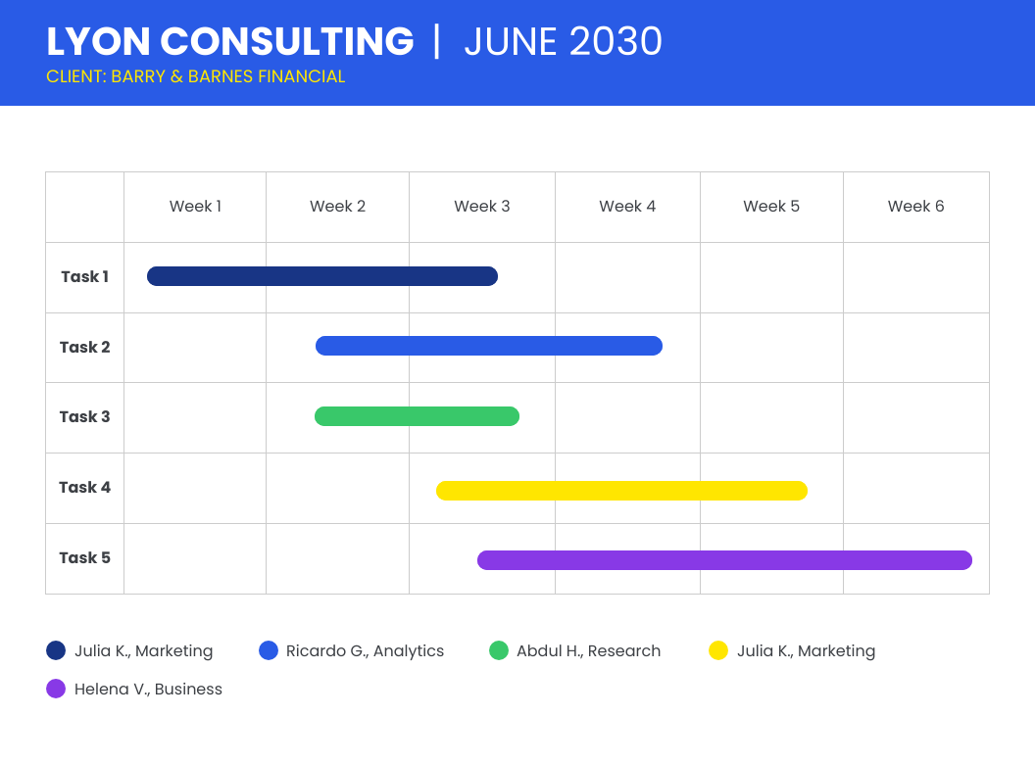

Summary of Costs

| **Control** | **Cost** |
| --- | --- |
|  |  |
|  |  |
|  |  |
| Total Cost |  |